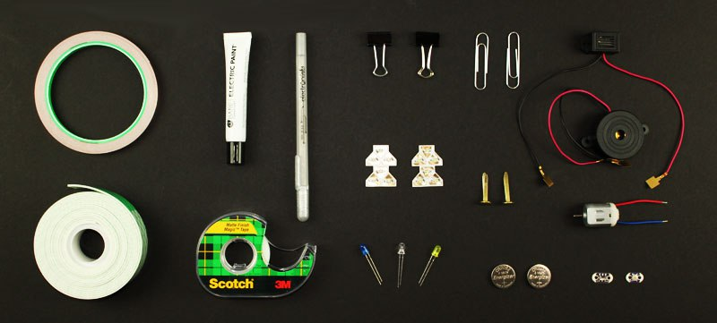
- Coin-cell battery (3V) CR2032
- Copper tape (1/4″) with conductive adhesive
- LED – 5mm, 10mm, surface mount or similiar
- DC Hobby motor – 130 size
- Buzzer – mechanical or piezo
- LilyPad button board or slide switch
- Paper clip or Binder clip
- Clear tape
- Double-sided foam tape
- Card stock paper – 65-110 lb
- Printer/copy paper
- Brass brads
- Circuit Stickers from Chibitronics (optional)
- Circuit Scribe – conductive ink pen (optional)
- Electric Paint from Bare Conductive (optional)

